How to run firstsample about push on bluemix

1.download android sdk for bluemix

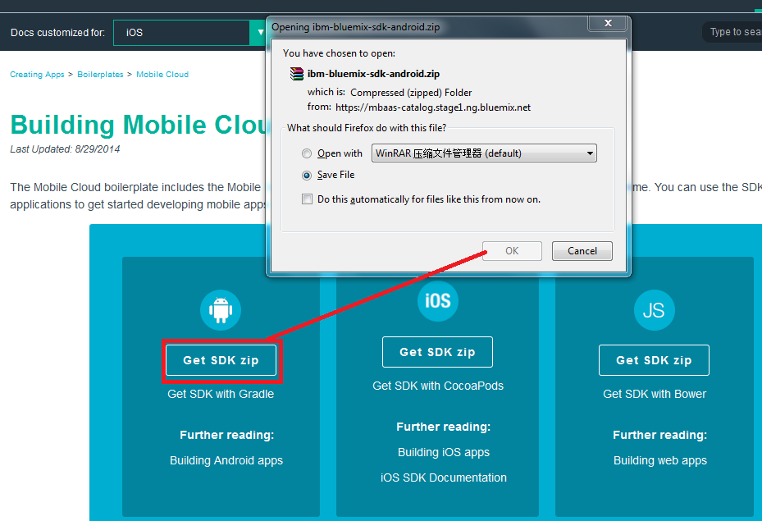

2.get sample project code from git reposite in eclipse
Git url : https://hub.jazz.net/git/mobilecloud/quickstart-push
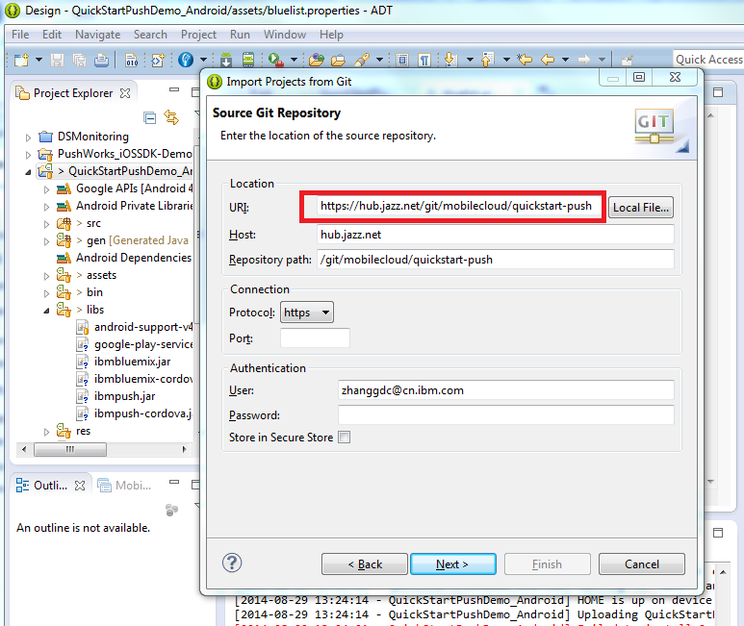

3.copy bluemix & Google Play Services library on android sdk into your project and add them in project build path.
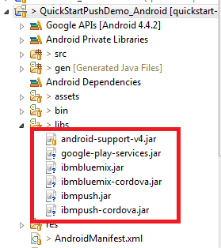
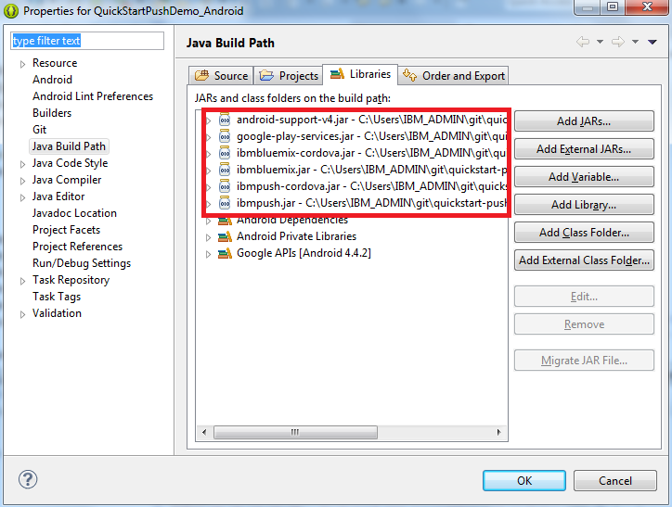
4.select build target
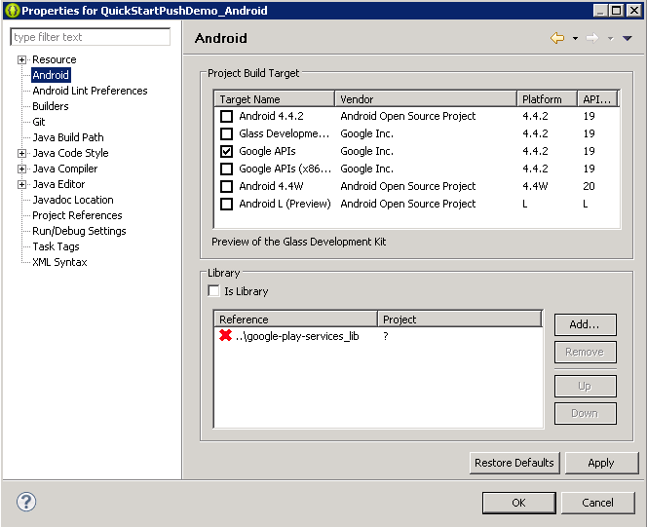
5.select google api & android lib
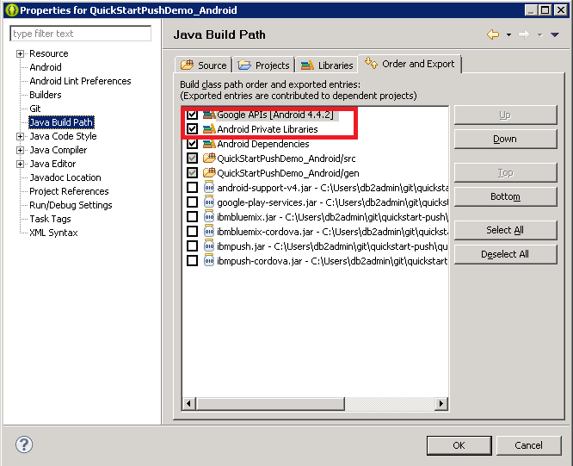

6.set right integer for gms version and right value for targetSdkVersion in AndroidManifest.xml
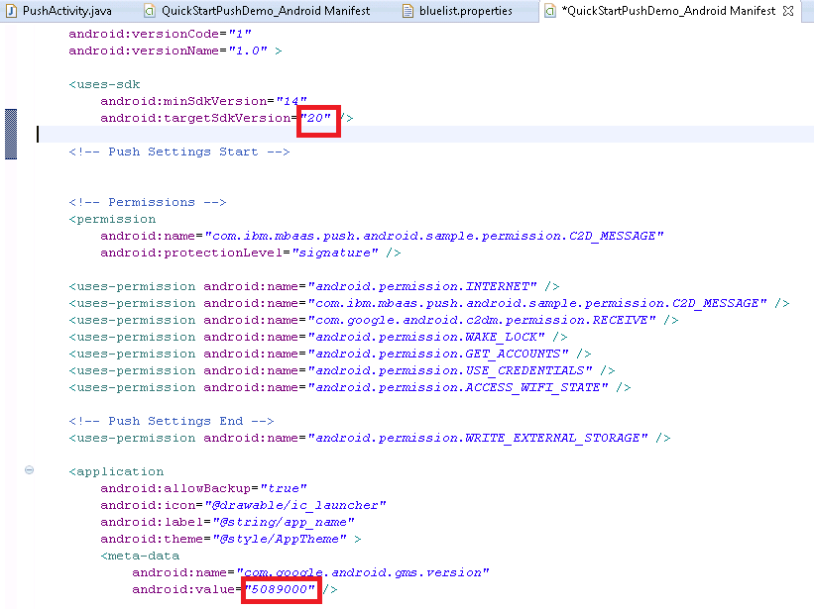
7. set value for applicationID, applicationSecret, applicationRoute in file bluelist.properties

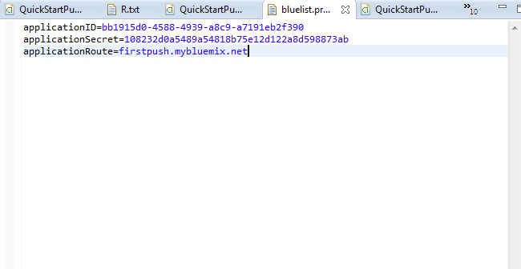

Before this step,you must set Google Cloud Messaging configuration on bluemix.
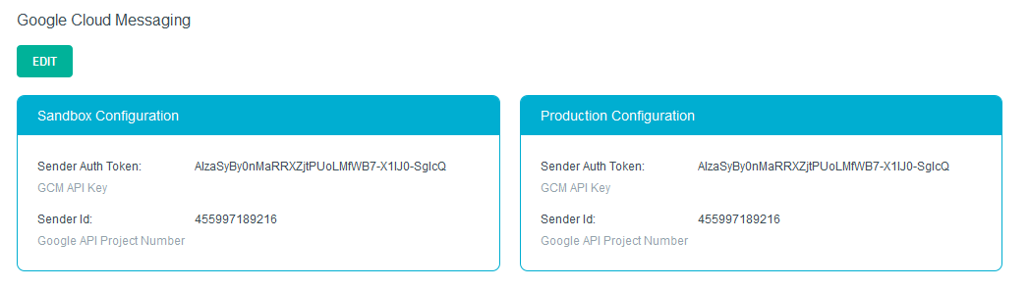

8.create virtual device

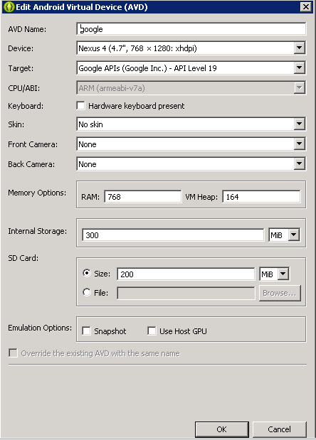
9. run app on emulator
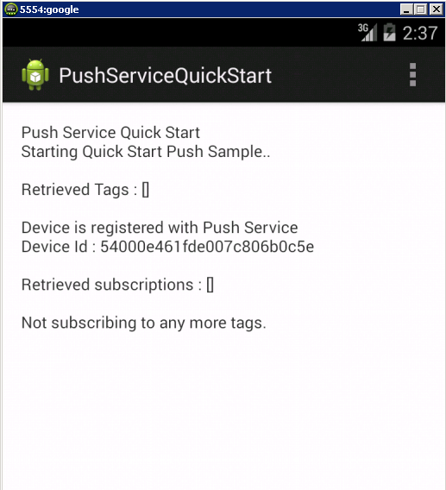
10.view push info on bluemix admin console
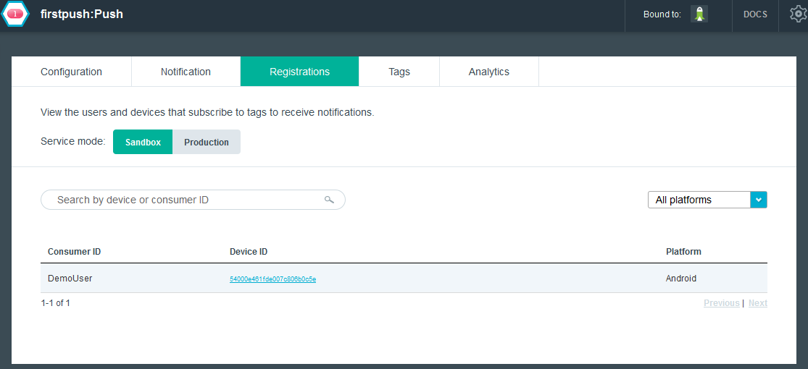
11.send push notification to register
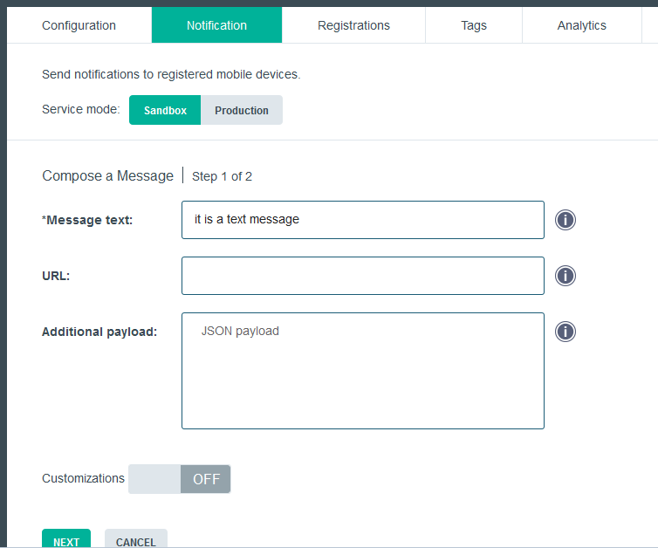
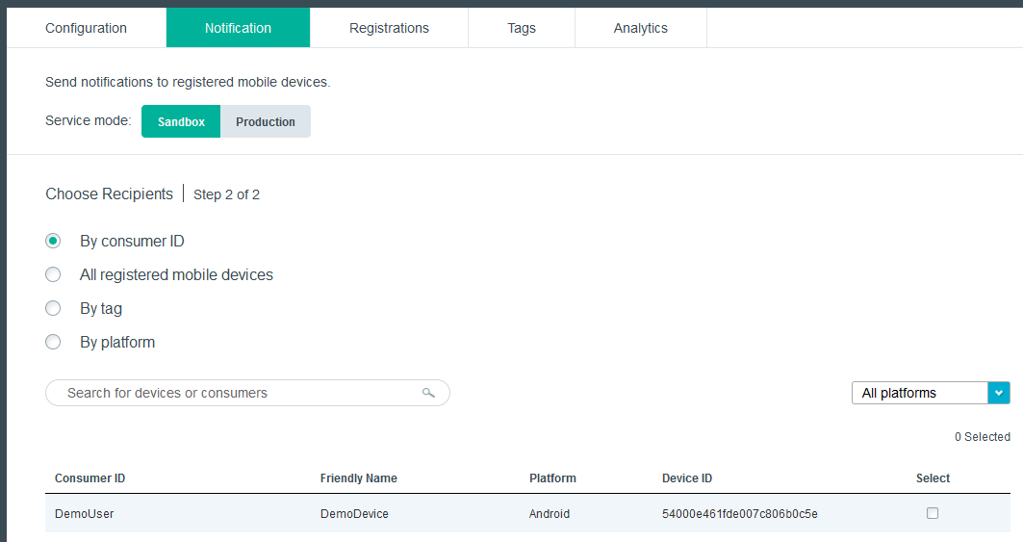
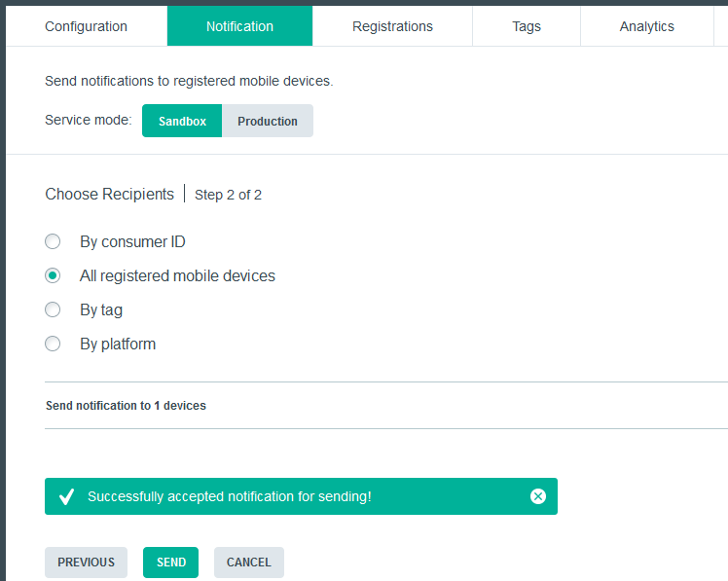

12.emulator received notification
